Augustus Mendy

Southern New Hampshire University

CS-499-10450-M01

Professor Ramsey

September 21, 2025

3-1 Journal Marketing With ePortfolios and Artifact Update

**Part One:**

In the IT industry, ePortfolios are essential. Considering how fresh to the field I am, I believe that ePortfolios are crucial because of the advantages of marketing and self-promotion. demonstrating my ability to troubleshoot coding bugs. And one of the best ways to promote my skills is to demonstrate that I can develop a program from the ground up. Receiving both good and negative feedback from a prospective employer after sending the ePortfolio is a confidence boost. I think it's vital to have both positive and negative criticism. I've read that problems arise even for experienced programmers. How we resolve the problem is what matters. I am aware, nevertheless, that there are drawbacks and dangers. It is somewhat stressful, for example, to put our best effort forward in order to receive feedback from an employer. What if the work turns out to be incorrect? It does not follow secure coding standards. queries like these can lead to other queries. However, it's crucial to keep in mind that the reward increases with the level of risk. It presents you and your work, regardless of how flawless or flawed it is. In my numerous interviews, I've discovered that while employers are interested in the work, they are even more interested in the person. In other words, you are not just showcasing your work to the company, but also your character. That's what matters most to me.

Part Two:

Thus, following a thorough review of my previous coursework and the input I've already gotten, I've chosen to focus on Austin Animal Center from CS-340.

1. **Software design and engineering,** For this category, I found a coding project that I was unable to produce correctly after listening to the criticism. Below, I've included a screenshot of the code and debugger. I believe I am still at status checkpoint 2 in terms of the status checkpoints because I have discovered a project that I can work on and finish before the term ends. Going over the beginning and working my way through to the end is my plan. I'll execute every line, row by row, and debug each time. I can then be sure that I'm headed in the right direction. Something seems missing to me. I'll review my earlier notes to see what the code is lacking.

1. **Algorithms and data structures.** In CS-260, I have chosen to work on Labs 1-3. I am able to work on and finish this assignment. The screenshot below illustrates that I do not have the finished code saved. I'm going to determine the structure and variables. As soon as the code is finished, I will send it in for evaluation. Therefore, since I am starting over following my unsuccessful attempts in modules 1 and 2, I think I am at status checkpoint

1. **Databases:** For this category, I've chosen to work on DAD-220's Lab 2. I was able to access CODIO and begin working on the code. A number of companies are seeking developers with database creation and management skills, which is why I chose this lab. Given that I am starting the code afresh, I would say that I am in status checkpoint 2. I'm going to make a table and fill it with information. After entering the data, I'll take a screenshot and send it in for evaluation.

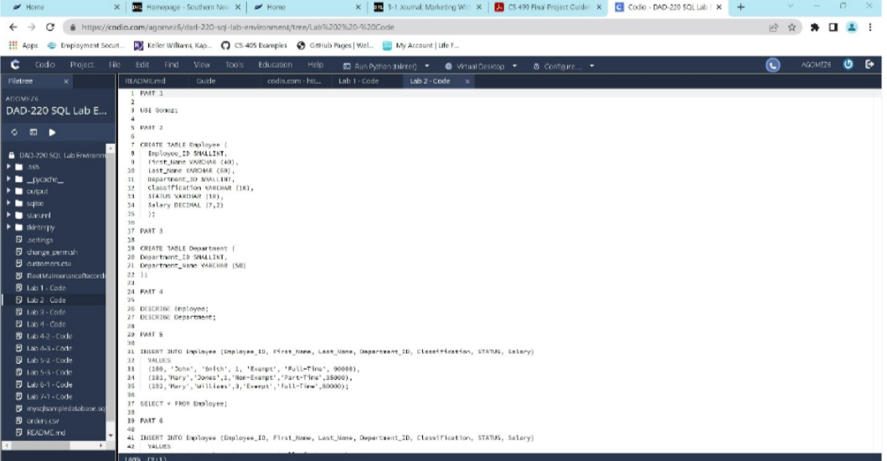

Finally, I would appreciate any and all comments. I would appreciate it if you could point out any errors in my code here. I will make every effort to demonstrate my ability to solve the issue and finish the project.